**CSA1054-SOFTWARE ENGINEERING**

**LAB EXPERIMENTS**

**Name: K.R.Chandana**

**Register no:192211987**

**Experiment 1:** Draw a use case diagram to model for Online Voting System. A web-based voting system that will help to manage elections easily and securely, the voter should be able to successfully cast his vote or it should be a failure. There should be no intermediate state. In case of failures the voter should be allowed to retry immediately. The voting data should be consistent throughout the system. If we are replicating the data, we do not want any scenario where one database shows Voter-1 has voted Candidate-1 and another database has an old entry for Voter-1 showing he has voted for Candidate-2. We should always have strong consistency.

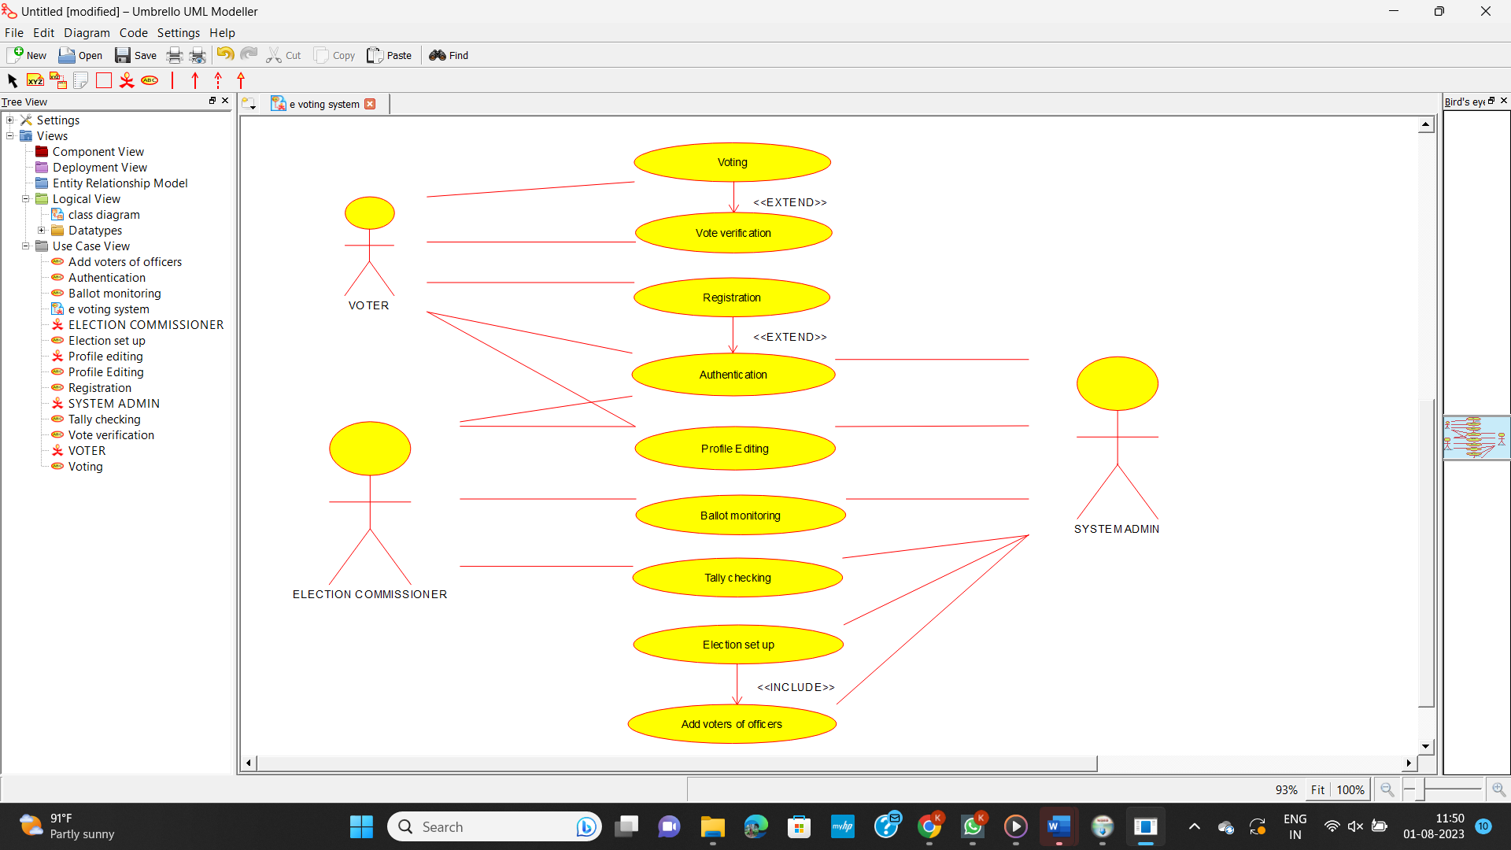

**Experiment 2:** Draw a use case diagram for Library Management System is an automation system used to manage a library and the different resource management required in it like cataloguing of books, allowing check out and return of books, invoicing, user management, etc. The user can search for book details using a few book properties (Book ID, Title, Author, and Publisher). Searching should return details about all the book copies that match the search query.

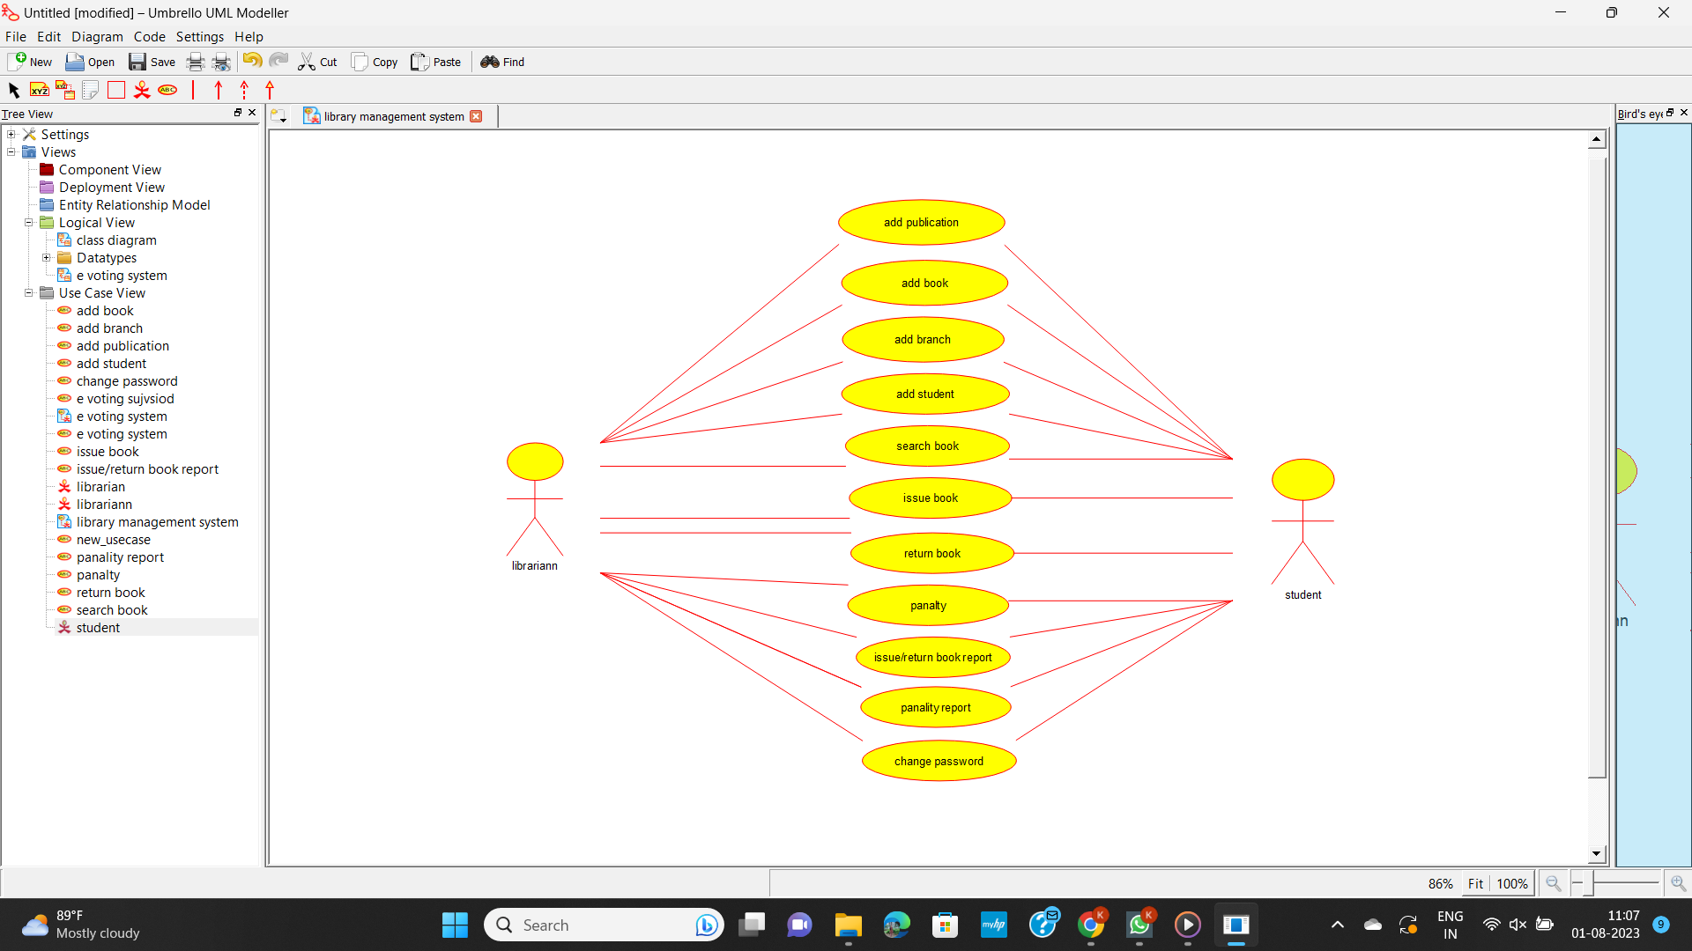

**Experiment 3:** Draw the use case diagram is a graphic depiction of the interactions among the elements of the Railway reservation system for maintaining admin user can search ticket, view the description of a selected ticket, add a ticket, update a ticket and delete a ticket and it shows the activity flow of editing, adding and updating of the customer. The user will be able to search and generate reports of payment, Booking and train schedules.

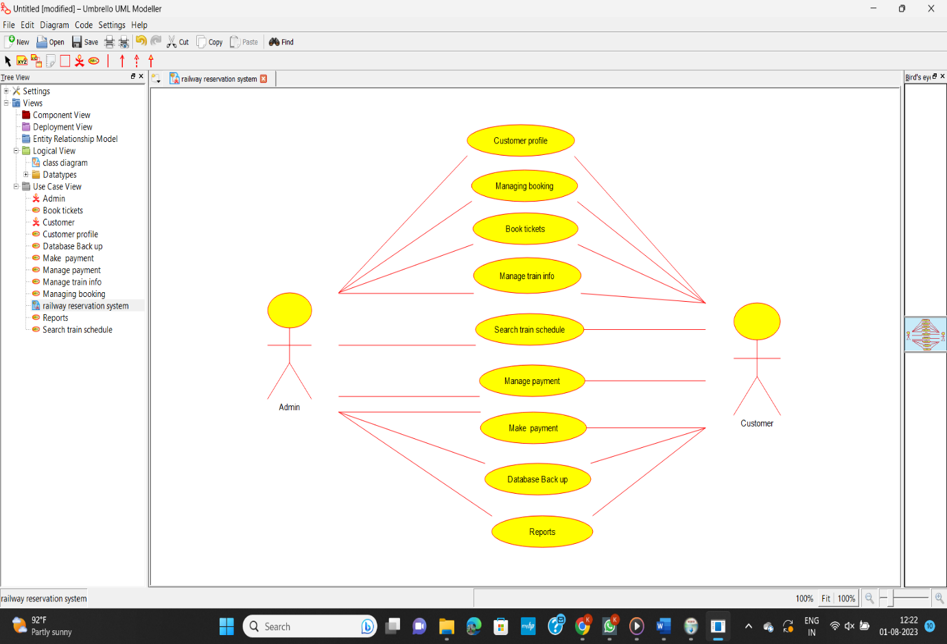

**Experiment 4:** Draw a USE-CASE diagram for the Hospital Management System. The activities of the hospital system are listed below. Receive the patient id, Patient name, pharmacy, laboratory, doctor, administrator, record officer, test report, drug management, test management, user management, dispense drug using CASE tools.

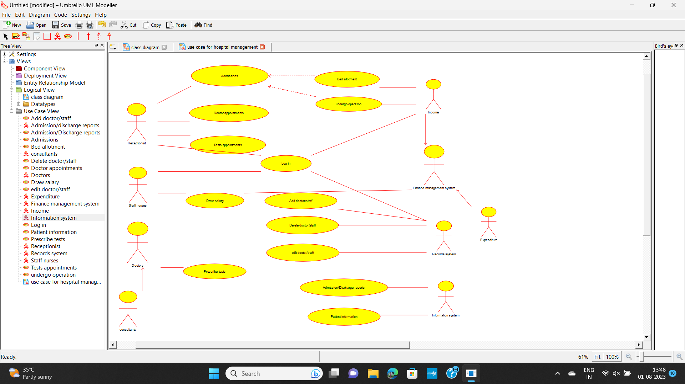

**Experiment 5:** Draw a USE-CASE diagram for an ATM System using CASE tool. The banking system allows a customer to access the financial transactions by ATM System; it has a step by step process describing the work of this process and elaborates what work can be done by customer, banking system, administrator and technicians with the ATM system.

